1. Weather Station Simulator
   1. Description of Sample Application

This example simulates a typical weather station consists of three main components i.e., WeatherStationSensor, Transmitter and a Receiver.

WeatherStationSensor, runs in a thread, generates weather-data readings at random intervals and temporary stores them in a queue, accessible to the Transmitter. On receiving a request weather-data from the Receiver in random intervals, the Transmitter sends all of the data available in the queue, one weather-data reading at a time and in order, to Receiver. Receiver periodically sends more requests for weather data if it don’t receive any data for some time period.

* 1. Current Design

Figure 1 shows an overview of the current architecture for WeatherStationSimulator and protocol messages. The system contains three main classes i.e., WeatherStationSensor, Transmitter and Receiver. WeatherStationSensor generates WeatherDataVector(s) (weather-sensitive observations). Transmitter collects WeatherDataVector(s) and sends them to the Receiver. Figure 2 describes the WeatherStationSensor design. The UML Sequence Diagram in Figure 3 shows the transmitter/receiver interactions in more details.

Application runs one instances of Transmitter and one instance of Receiver. Transmitter starts its own WeatherStationSensor thread. The sensor combines the readings from its various sub-components (Figure 2) into a WeatherDataReading object. It then generates an instance of WeatherDataVector message, and populates it with four WeatherDataReading instances, at random intervals, and stores in a temporary data structure.

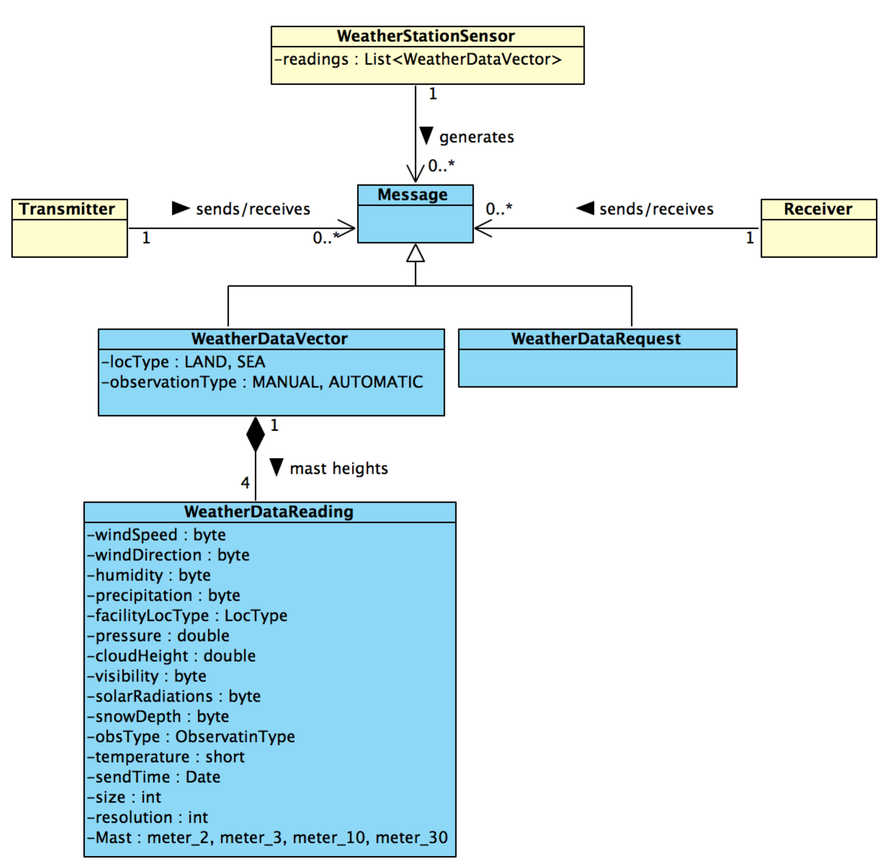

Figure 1: Data Structures for Weather Station Simulator example

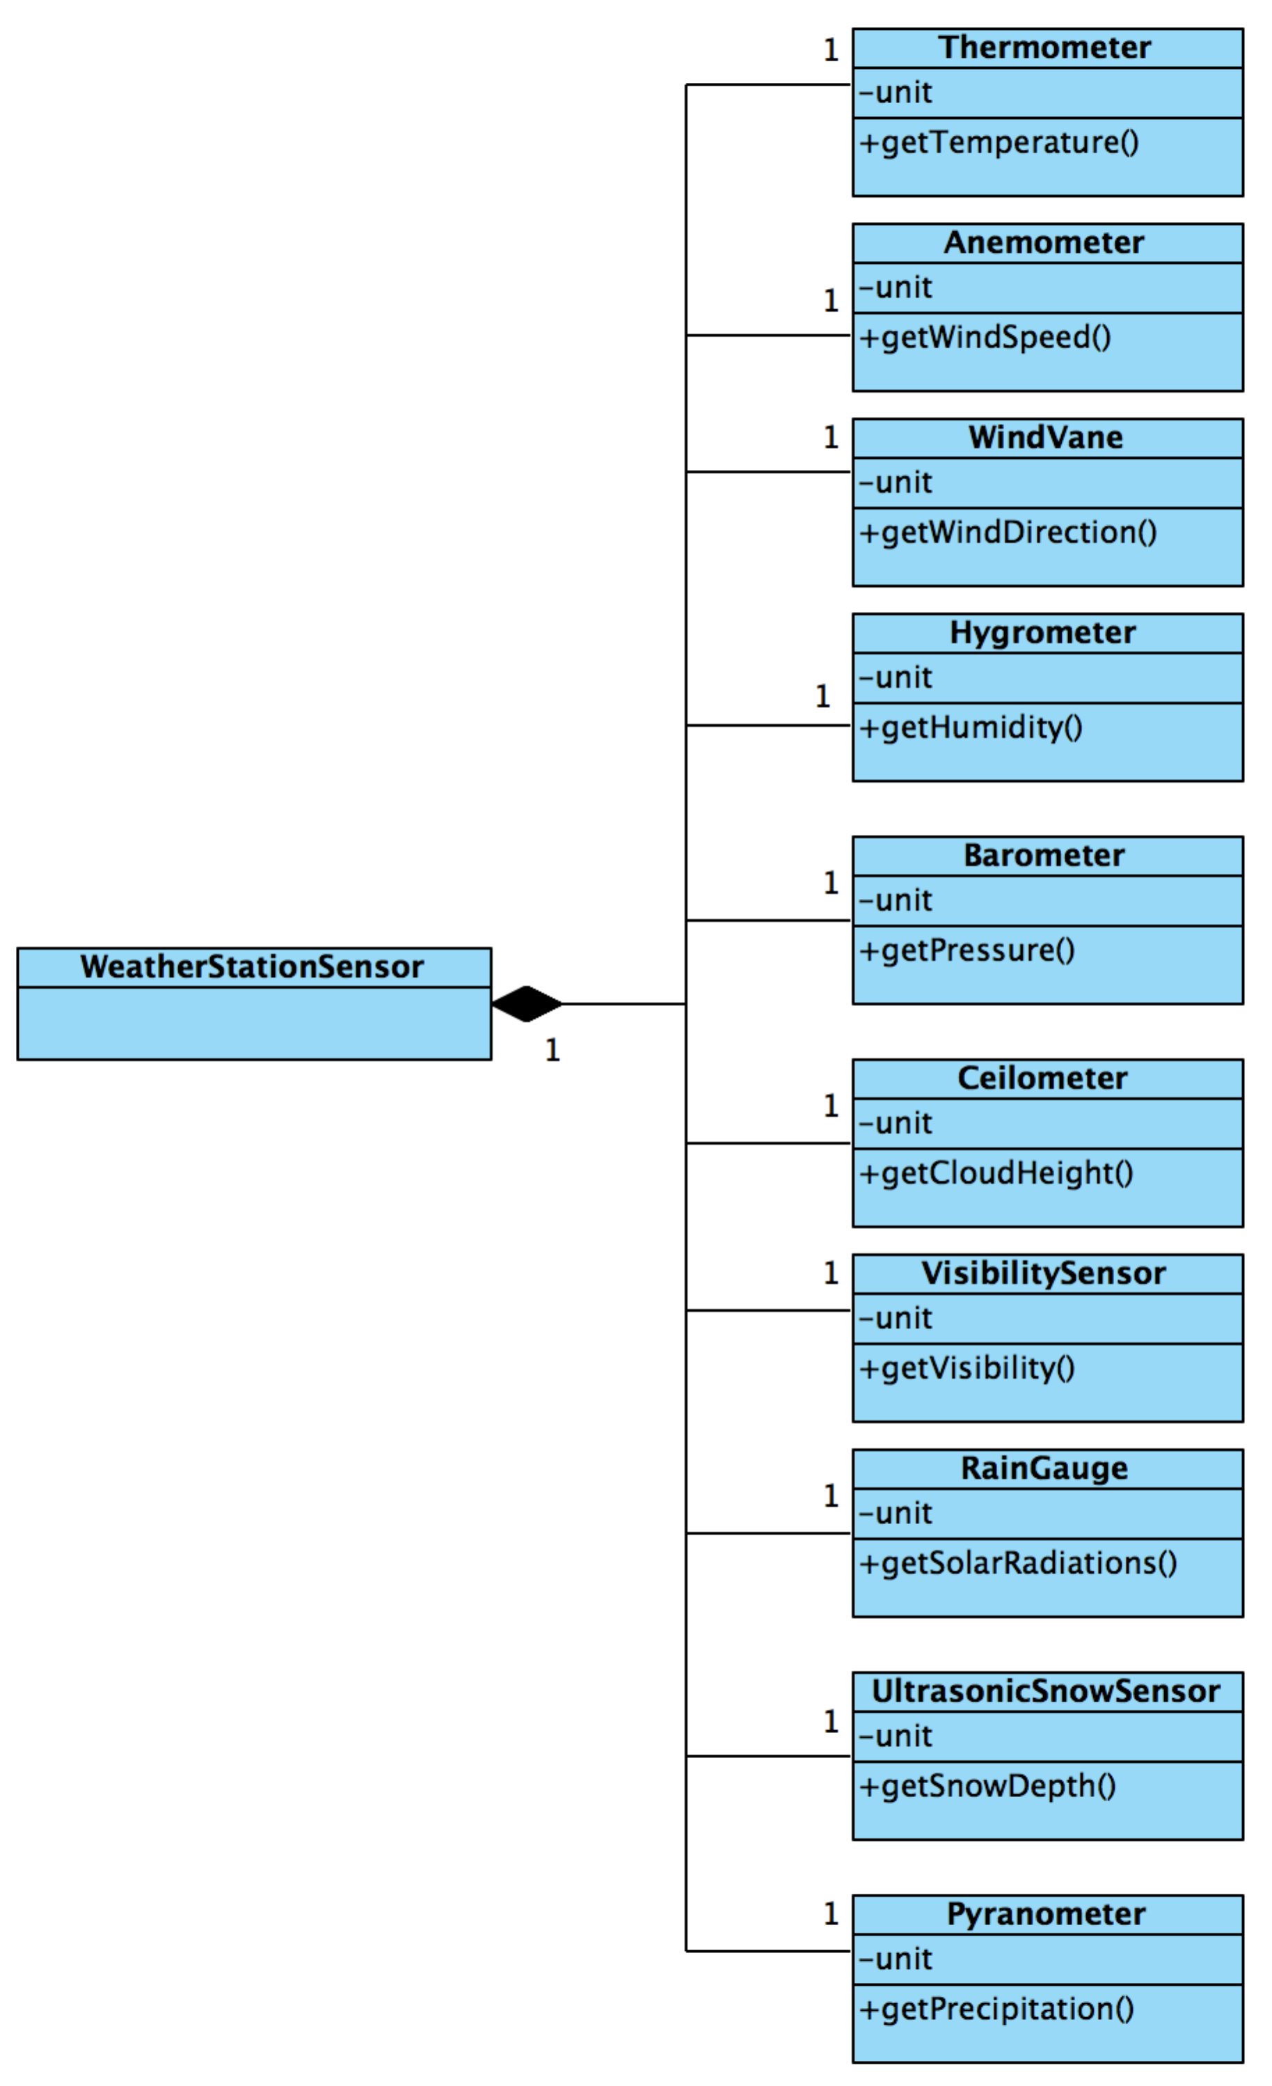

Figure 2: Weather Station Simulator

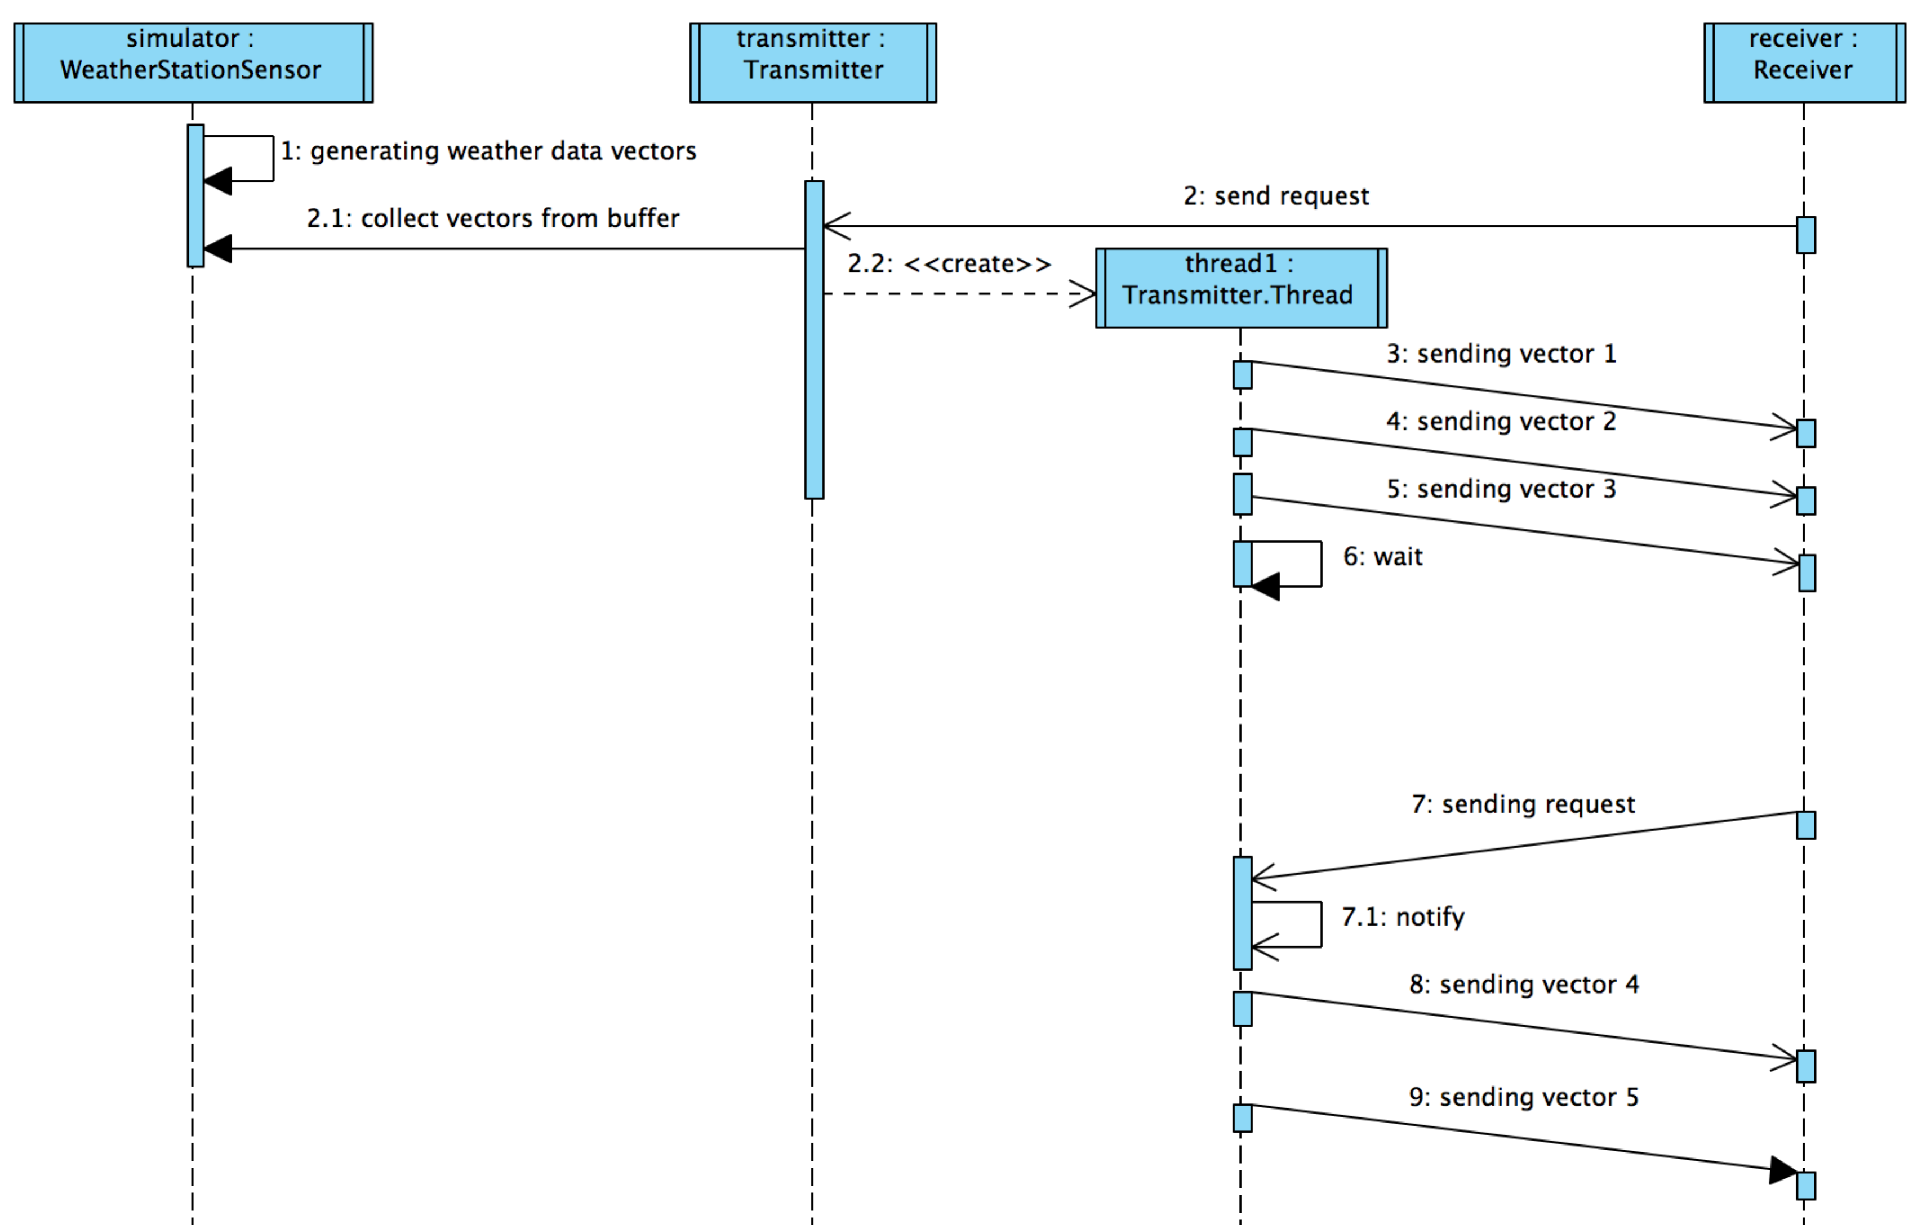

Figure 3: Interaction diagram between Transmitter and Receiver

|  |  |
| --- | --- |
| ***Term*** | **Description** |
| *Thermometer* | It is used for measuring temperature |
| *Anemometer* | It is used *for measuring wind speed* |
| *Wind vane* | It is used for measuring wind direction |
| *Hygrometer* | It is used for measuring humidity |
| *Barometer* | It is used for measuring atmospheric pressure |
| *Ceilometer* | It is used for measuring cloud height |
| *visibility sensor* | It is used for measuring visibility |
| *Rain gauge* | It is used for measuring liquid-equivalent precipitation |
| *Ultrasonic snow sensor* | It is used for measuring depth of snow |
| *Pyranometer* | It is used for measuring solar radiations |
| *Mast Heights* | A pole, or long, strong, round piece of timber, or spar, set upright in a boat or vessel to note weather readings |